## **PIVOTAL CLOUD FOUNDRY POV**

Contents

**PIVOTAL CLOUD FOUNDRY POV** 1

1. Audit Central 2

2. Claim Random Sample Generator (CRSG) 3

3. Vendor Self Audit (VSA) 4

4. Total Loss Calculator 4

**5.** Tabular Reserve 5

**6.** Recovery Processing Service (RPS) 6

# Audit Central

Claim Performance Handling team, Centralized auditing tool to identify the health of the Claim, on how it was handles

* 1. **INTERFACES**

CRSG, Claim Learning Auditing DB, to audit trainer, Employee DB to add users, replaced by HR feed, Oracle Data ware house

* 1. **TECHNOLOGY STACK:**

ASP.NET MVC, SQL SERVER, .Net 4.5.2

* 1. **ISSUES FACED:**

1. Oracle.DataAccess: system currently using x86 dll, but the PCF windows elastic runtime was a x64 machine

**Step taken:** Changed the dll to use Oracle.DataAccess to use the x64 version

1. SQL Connectivity Issue: Unable to connect to SQL server from PFC

**Step Taken:** identified the port number and the Protocol for SWL server from PCF and updated ISSR, got the port opened on 12/14/2017

1. Unable to Authenticate User: Audit central uses Windows Authentication, Craig from PCF suggested to use Active Directory Registration service for the long run

**Step Taken**: we bypassed the authentication for the POV and most features of Audit central were accessible ad working

* 1. **PATTERNS OBSERVED/VALIDATED**

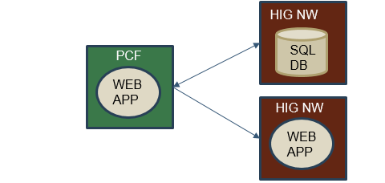

* 1. **Code Changes:**

Files Modified: ~6

Lines of Code: ~30,000

Lines of code Modified: ~45-50

# Claim Random Sample Generator (CRSG)

**2.1 INTERFACES**

Audit Central, CRSG Database, Employee DB to add users, replaced by HR feed, Oracle Data ware house

**2.2 TECHNOLOGY STACK:**

ASP.NET, SQL SERVER, .Net 4.5.2

**2.3 ISSUES FACED:**

1. Unable to Authenticate User: Audit central uses Windows Authentication, Craig from PCF suggested to use Active Directory Registration service for the long run

**Step Taken**: we bypassed the authentication for the POV and most features of Audit central were accessible ad working

1. Unable to connect to web service due to SSL/TSL certificate

**Step Taken:** Working with Hartford CA to create a trusted CA to be installed on PCF

As a workaround to make CRSG work changed code to directly reference the Server side code

1. SQL Connectivity Issue: Unable to connect to SQL server from PFC

**Step Taken:** identified the port number and the Protocol for SWL server from PCF and updated ISSR, got the port opened

* 1. **PATTERNS OBSERVED/VALIDATED**

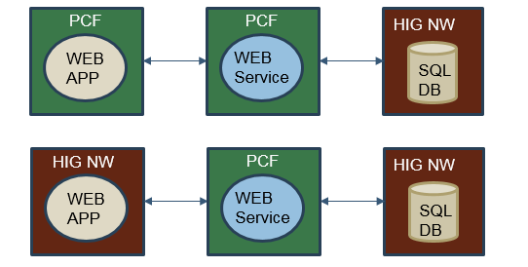

* 1. **CODE CHANGES:**

Files Modified: ~3

Lines of Code: ~13,000

Lines of code Modified: ~20

# Vendor Self Audit (VSA)

* 1. **INTERFACES**

VSA database, Oracle Data ware house

* 1. **TECHNOLOGY STACK:**

ASP.NET, SQL SERVER, .Net 4.5.2

* 1. **ISSUES FACED:**

1. SQL Connectivity: Unable to connect to SQL server from PFC

**Step Taken:** identified the port number and the Protocol for SWL server from PCF and updated ISSR, got the port opened

1. Application was navigating to logout page all the time:

**Step Taken:** Code had to be changed to make it work on PCF, logic had to be changed

* 1. **PATTERNS OBSERVED/VALIDATED**

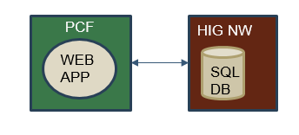

* 1. **CODE CHANGES:**

Files Modified: ~3

Lines of Code: ~15,000

Lines of code Modified: ~20

# Total Loss Calculator

* 1. **INTERFACES**

SQL database, Oracle Data ware house

* 1. **TECHNOLOGY STACK:**

ASP.NET, SQL SERVER, .Net 4.5.2

* 1. **ISSUES FACED:**

1. Windows Authentication

**Step Taken**: we bypassed the authentication for the POV

1. SQL Connectivity Issue: Unable to connect to SQL server from PFC

**Step Taken:** identified the port number and the Protocol for SWL server from PCF and updated ISSR, got the port opened

* 1. **PATTERNS OBSERVED/VALIDATED**



* 1. **CODE CHANGES:**

Files Modified: ~3

Lines of Code: ~5,700

Lines of code Modified: ~20

# Tabular Reserve

* 1. **INTERFACES**

SQL database, Oracle Data ware house, MQ Web service

* 1. **TECHNOLOGY STACK:**

ASP.NET, SQL SERVER, .Net 4.5.2

* 1. **ISSUES FACED:**

1. Windows Authentication

**Step Taken**: we bypassed the authentication for the POV

1. SQL Connectivity Issue: Unable to connect to SQL server from PFC

**Step Taken:** identified the port number and the Protocol for SWL server from PCF and updated ISSR, got the port opened

* 1. **PATTERNS OBSERVED/VALIDATED**

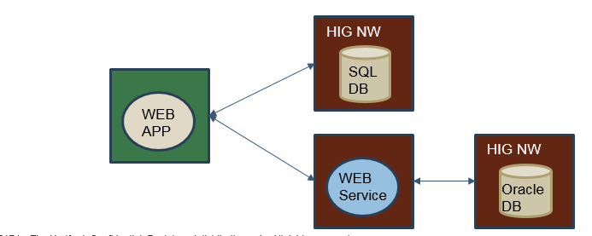

* 1. **CODE CHANGES:**

Files Modified: ~3

Lines of Code: ~15,000

Lines of code Modified: ~20

# Recovery Processing Service (RPS)

* 1. **INTERFACES**

SQL database, Oracle Data ware house, MQ Web service, SSRS

* 1. **TECHNOLOGY STACK**

ASP.NET, SQL SERVER, .Net 4.5.2

* 1. **ISSUES FACED:**

1. Windows Authentication

**Step Taken**: we bypassed the authentication for the POV

1. SQL Connectivity Issue: Unable to connect to SQL server from PFC

**Step Taken:** identified the port number and the Protocol for SWL server from PCF and updated ISSR, got the port opened

* 1. **PATTERNS OBSERVED/VALIDATED**

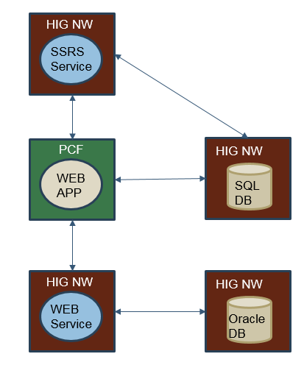

* 1. **CODE CHANGES:**

Total Lines of code in App: ~4,500

Files Modified: ~10

Lines of code Modified: ~50